Banker’s Algorithm – Deadlock Checker
A Project Based Learning Report Submitted in partial fulfilment of the requirements for the award of the degree

of

Bachelor of Technology
in The Department of Electronics and Communication Engineering
Operating Systems & System Programming – [25CS2104E]

Submitted by
2510030162:A.MANASWEE
2510030224: K.TEJA SRI
2510030097: M.SNIGDHA

Under the guidance of
DR.SEENU



Department of Electronics and Communication Engineering
Koneru Lakshmaiah Education Foundation, Aziz Nagar
Aziz Nagar – 500075
OCT - 2026.
Abstract

Deadlock is a condition in which a set of processes waits indefinitely for resources that are held by one another, leaving the system unable to make further progress. Among the strategies used by operating systems to handle this problem, deadlock avoidance is attractive because a resource request is granted only when the resulting state is guaranteed to be safe. This project implements Dijkstra’s Banker’s Algorithm as a Deadlock Checker in the C programming language.
The program takes the Allocation matrix, the Max matrix and the Available vector as input, computes the Need matrix using Need = Max − Allocation, and then runs the safety algorithm using a Work vector and a Finish array. If every process can be made to finish, the system is reported to be in a SAFE state and a safe sequence is displayed; if at some stage no unfinished process satisfies Need ≤ Work, the system is declared UNSAFE.
The implementation was compiled with GCC and executed on a Linux / Ubuntu (WSL) platform. Three test cases were used: a safe state with the safe sequence P1 → P3 → P2, an unsafe state, and an exact-fit boundary condition in which Need equals Work. In every case the observed behaviour matched the expected result, confirming the Need calculation, Work-vector update, Finish tracking, safe-sequence generation, unsafe-state detection and the inclusive ≤ comparison. Future work includes runtime user input, live resource-request handling, rejection of unsafe requests, input validation and larger test cases.
Keywords: Deadlock avoidance, Banker’s Algorithm, Safe state, Safe sequence, Operating Systems, C programming

List of Figures

Fig. 1. System design of the Banker’s Algorithm Deadlock Checker 7
Fig. 2. Implementation workflow (flowchart) of the safety algorithm 9
Fig. 3. Program output for Test Case 1 – safe state with safe sequence P1 → P3 → P2 10
Fig. 4. Program output for (a) Test Case 2 – unsafe state and (b) Test Case 3 – exact-fit condition 11
Fig. 5. Evolution of the Work vector while the safe sequence P1 → P3 → P2 is executed 12

List of Tables

TABLE I. Data structures used in the implementation 7
TABLE II. Development environment 9
TABLE III. Test Case 1 – safe state input data, Available = [3, 3, 2] 10
TABLE IV. Test Case 2 – unsafe state input data, Available = [1, 0, 0] 10
TABLE V. Test Case 3 – exact-fit input data, Available = [2, 2, 1] 11
TABLE VI. Summary of test cases and results 11

Table of Contents
1. Introduction 6
a. Background 6
b. Problem Statement 6
c. Objectives 7
2. Methodology 7
a. System Design 7
b. Need Calculation 7
c. Safety Algorithm 8
d. Implementation Workflow 8
e. Development Environment 9
3. Experiments 9
a. Test Case 1 – Safe State 9
b. Test Case 2 – Unsafe State 10
c. Test Case 3 – Exact Fit Condition 11
4. Results 11
a. Test Summary 11
b. Behaviour of the Work Vector 12
c. Verified Functionality 12
5. Conclusion and Future Work 12
References 13
Appendix A: C Source Code 13

Banker’s Algorithm – Deadlock Checker

Introduction
Every modern operating system is responsible for sharing a limited set of resources, such as the CPU, main memory, files, printers and other I/O devices, among many processes that run concurrently. When several processes compete for the same resources, a situation called deadlock can arise: a set of processes becomes permanently blocked because each process in the set holds at least one resource and is waiting for a resource that is held by another process in the same set. A simple example is two processes where the first holds a scanner and requests a printer, while the second holds the printer and requests the scanner. Neither request can ever be satisfied, neither process can make progress, and the resources they hold remain unusable for the rest of the system.

Deadlock can occur only when four conditions hold at the same time [3]. These are mutual exclusion (a resource can be used by only one process at a time), hold and wait (a process keeps the resources it has while waiting for more), no pre-emption (a resource cannot be forcibly taken away from a process) and circular wait (a closed chain of processes exists in which each process waits for a resource held by the next). Operating systems deal with deadlocks in one of four broad ways: they can prevent deadlock by making at least one of the four conditions impossible, avoid deadlock by examining every request before granting it, detect and recover after a deadlock has occurred, or simply ignore the problem when it is rare. Prevention is simple but often wastes resources, while detection and recovery may require terminating processes. Deadlock avoidance sits between the two: it allows the full flexibility of dynamic allocation but still guarantees that the system never enters a state from which deadlock is unavoidable [4], [5].

Background

The best-known avoidance technique is the Banker’s Algorithm, proposed by E. W. Dijkstra [1] and generalised by Habermann [2]. The name comes from a banking analogy: a banker has a limited amount of capital and several customers, each with a maximum credit line. The banker approves a loan only if, after approving it, there is still some order in which every customer can be given the maximum credit they asked for and eventually repay the loan. In the operating-system setting, the customers are processes, the money is a set of resource types with a fixed number of instances, and each process declares in advance the maximum number of instances of each resource it may ever need.
A system is said to be in a safe state if there exists at least one ordering of the processes, called a safe sequence, in which every process can obtain the resources it still needs from those currently free plus those released by the processes that finished before it. If no such ordering exists, the state is unsafe. An unsafe state does not always lead to deadlock, but it removes the guarantee that deadlock can be avoided, so a system that uses the Banker’s Algorithm refuses any request that would move it from a safe state into an unsafe one.

Problem Statement
Consider a system with n processes and m resource types. For every process the amount of each resource currently allocated and the maximum amount it may demand are known, and the number of free instances of each resource is also known. The problem is to decide whether this system is in a safe state and, when it is, to produce a safe sequence in which all processes can run to completion. Performing this check manually becomes slow and error-prone as the number of processes and resources grows, since the Need of each process must be recomputed and compared against the changing number of free resources after every step. A program that carries out the check systematically is therefore required.

Objectives
The objectives of this project are:
- Implement the Banker’s Algorithm using the C programming language.
- Check whether the given system is in a SAFE or an UNSAFE state.
- Generate a safe sequence whenever the system is safe.
The core relation used throughout the project is Need = Max − Allocation, and the overall goal is to prevent resource allocation from ever entering an unsafe state.

Methodology

System Design
The Deadlock Checker is organised as a four-stage pipeline, shown in Fig. 1. The input stage supplies three pieces of information: the Allocation matrix (resources currently held by each process), the Max matrix (maximum resources each process may require) and the Available vector (resources currently free). The second stage derives the Need matrix, which gives the remaining requirement of every process. The third stage runs the safety check, which repeatedly looks for a process whose remaining need can be satisfied by the currently available resources. The final stage reports the result as SAFE or UNSAFE and, in the safe case, prints the safe sequence. Table I lists the data structures used by the program.

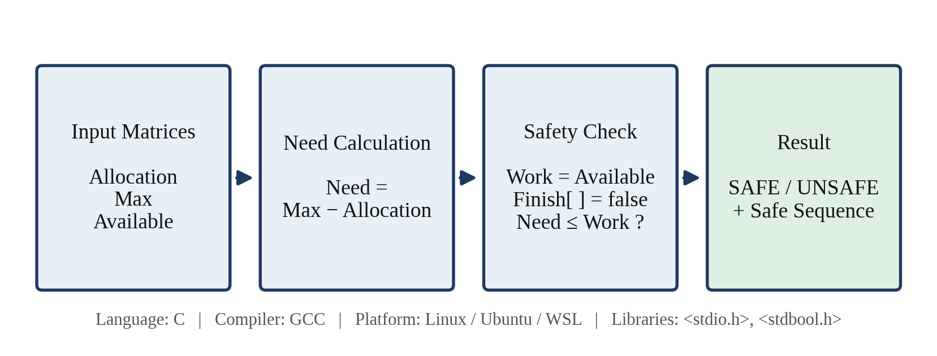
- System design of the Banker’s Algorithm Deadlock Checker

- Data structures used in the implementation
Structure | Dimension | Meaning
Allocation | n × m matrix | Resources currently held by each process
Max | n × m matrix | Maximum resources each process may require
Available | vector of m | Resources that are currently free
Need | n × m matrix | Remaining resources required, Max − Allocation
Work | vector of m | Working copy of Available; grows as processes finish
Finish | array of n | Boolean flag, true once a process has been able to complete

Need Calculation
The Max matrix describes the total demand of each process, but part of that demand has already been satisfied through the current allocation. The remaining requirement of process Pi for resource Rj is therefore calculated as
Need[i][j] = Max[i][j] − Allocation[i][j] (1)
For example, in the first test case process P2 has Max = [7, 4, 4] and Allocation = [2, 1, 1], so its Need is [5, 3, 3]. The Need matrix is calculated once, before the safety check begins, and is not modified afterwards.

Safety Algorithm
The safety algorithm decides whether a safe sequence exists. It uses the Work vector and the Finish array described in Table I and proceeds in the following steps.
Step 1: Initialise Work = Available and set Finish[i] = false for every process i.
Step 2: Find a process Pi such that Finish[i] = false and Need[i] ≤ Work. The comparison is made component by component, so every resource type must be satisfied.
Step 3: If such a process is found, assume it runs to completion and releases everything it holds: Work = Work + Allocation[i], Finish[i] = true. Record Pi in the safe sequence and return to Step 2.
Step 4: If no such process exists, stop the search.
Step 5: If Finish[i] = true for all processes, the system is in a SAFE state and the recorded order is a safe sequence. Otherwise the system is UNSAFE.
The comparison in Step 2 is deliberately inclusive: a process whose Need is exactly equal to Work is allowed to execute, because it can still obtain every resource it asks for. Each pass over the process list either completes at least one process or ends the search, so at most n passes are needed, and each pass performs at most n × m comparisons. The time complexity is therefore O(m × n²).

Implementation Workflow
Fig. 2 shows the workflow followed by the program. After reading Allocation, Max and Available, the program computes Need and copies Available into Work. It then enters the main loop, which looks for an unfinished process with Need ≤ Work. When one is found, its allocation is added to Work, it is marked finished and appended to the safe sequence; the program then checks whether all processes have finished. If they have, the SAFE state is reported together with the safe sequence. If at any point no candidate process exists, the loop ends and the UNSAFE state is reported.

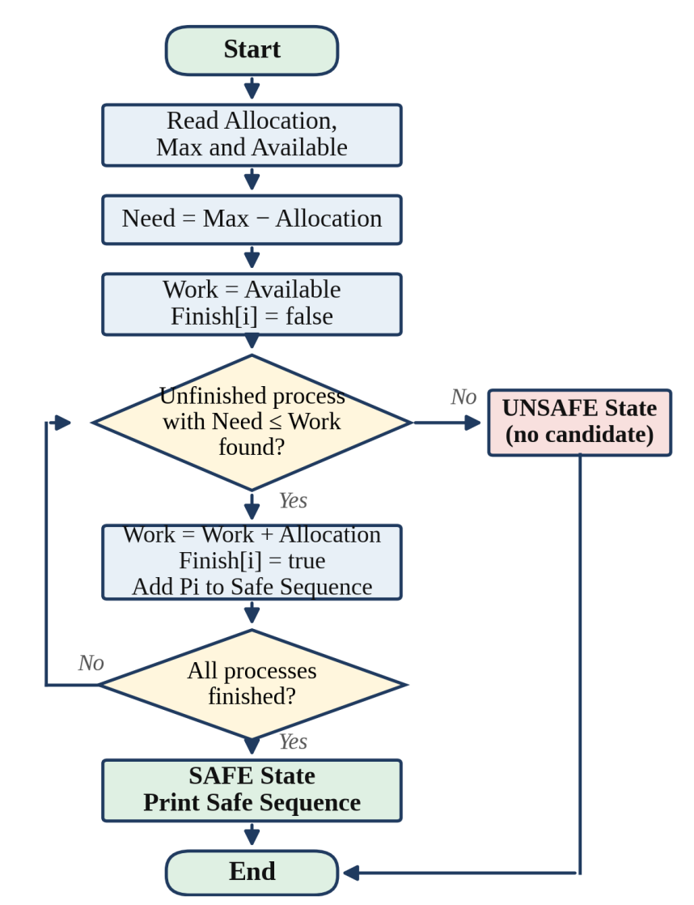
- Implementation workflow (flowchart) of the safety algorithm

Development Environment
The program is written in standard C and uses only two header files from the C library. Table II summarises the environment. The program is compiled and run from the terminal with the commands gcc bankers.c -o bankers and ./bankers.

- Development environment
Item | Details
Programming language | C
Compiler | GCC
Platform | Linux / Ubuntu / WSL
Libraries | <stdio.h> for input and output, <stdbool.h> for the bool type

Experiments
Three test cases were designed to exercise the three situations that the Deadlock Checker must handle correctly: a system that is safe, a system that is unsafe, and a boundary case in which the remaining need of a process is exactly equal to the resources available. In all three cases the system has three processes (P1, P2, P3) and three resource types, and the data are supplied to the program as the Allocation matrix, Max matrix and Available vector.

Test Case 1 – Safe State
The first test case uses Available = [3, 3, 2] with the data given in Table III. The Need matrix computed by the program is P1: [2, 2, 2], P2: [5, 3, 3] and P3: [1, 0, 0].
- Test Case 1 – safe state input data, Available = [3, 3, 2]
Process | Allocation | Max | Need
P1 | 1 0 0 | 3 2 2 | 2 2 2
P2 | 2 1 1 | 7 4 4 | 5 3 3
P3 | 2 1 1 | 3 1 1 | 1 0 0

The execution trace is as follows. Work starts as [3, 3, 2]. P1 has Need [2, 2, 2] ≤ Work, so it can execute; after it finishes, Work becomes [4, 3, 2]. P2 cannot execute yet because its Need [5, 3, 3] is larger than Work, so the search moves on to P3, whose Need [1, 0, 0] ≤ [4, 3, 2]; after P3 finishes, Work becomes [6, 4, 3]. Now P2 satisfies [5, 3, 3] ≤ [6, 4, 3] and can finish. All processes complete, so the system is SAFE with the safe sequence P1 → P3 → P2. The output produced by the program is shown in Fig. 3.
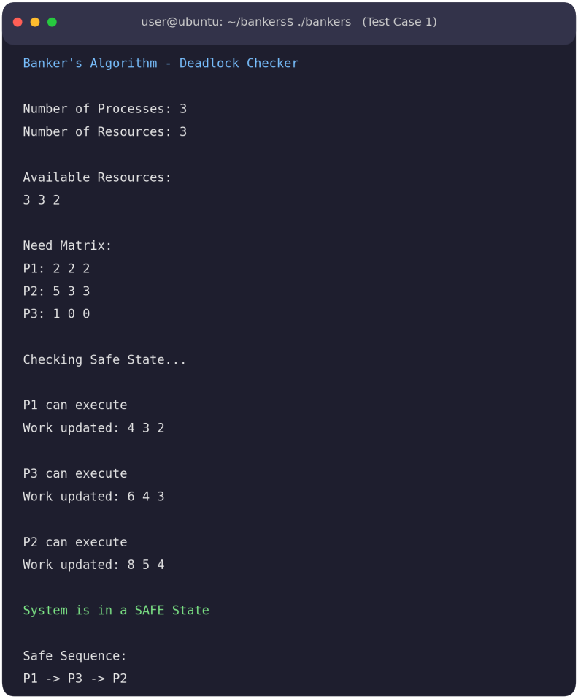
- Program output for Test Case 1 – safe state with safe sequence P1 → P3 → P2

Test Case 2 – Unsafe State
The second test case represents a request that exceeds the available limits. The data in Table IV leave only one free instance of the first resource and none of the others. The Need of P1 is [2, 2, 2], of P2 is [5, 3, 3] and of P3 is [1, 1, 0]. Each of them asks for more than the available [1, 0, 0] in at least one resource type, so no unfinished process satisfies Need ≤ Work. The safe sequence cannot be completed and the program reports that the system is in an UNSAFE state (Fig. 4a).
- Test Case 2 – unsafe state input data, Available = [1, 0, 0]
Process | Allocation | Max | Need
P1 | 1 0 0 | 3 2 2 | 2 2 2
P2 | 2 1 1 | 7 4 4 | 5 3 3
P3 | 2 1 1 | 3 2 1 | 1 1 0

Test Case 3 – Exact Fit Condition
The third test case checks the boundary condition Need = Work. Process P1 has Need = [2, 2, 1] and the available resources are also [2, 2, 1] (Table V). Because the comparison is inclusive, Need ≤ Work is true and P1 is allowed to execute. When P1 completes it releases its resources, Work increases to [3, 2, 2], and the remaining processes can then execute in turn. P1 is selected in the first pass solely because of the equality; a strict “<” comparison would have skipped it. The program output is shown in Fig. 4b.

- Test Case 3 – exact-fit input data, Available = [2, 2, 1]
Process | Allocation | Max | Need
P1 | 1 0 1 | 3 2 2 | 2 2 1
P2 | 2 1 1 | 7 4 4 | 5 3 3
P3 | 2 1 1 | 3 1 1 | 1 0 0

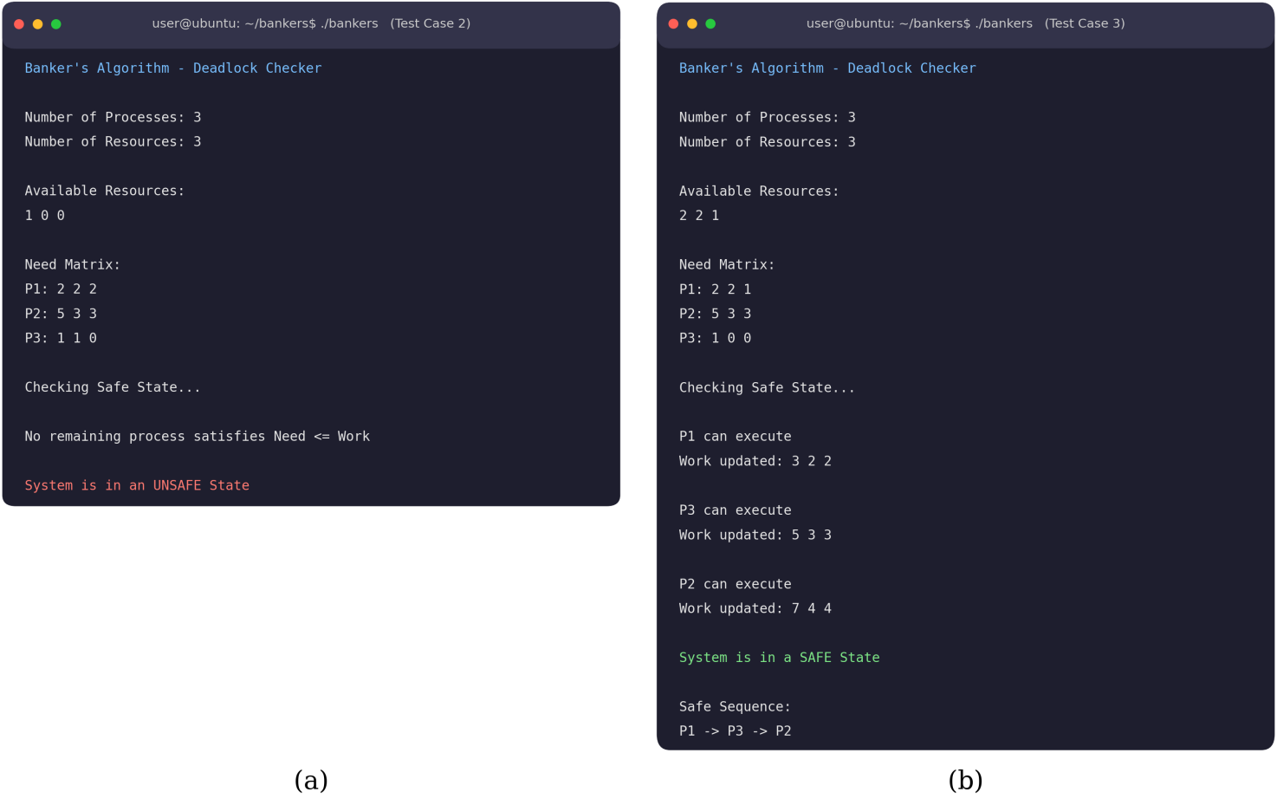
- Program output for (a) Test Case 2 – unsafe state and (b) Test Case 3 – exact-fit condition

Results

Test Summary
Table VI compares the expected and the observed result for each test case. The program produced the expected result in every case: the safe state was recognised and a complete safe sequence was generated, the unsafe state was detected when no process satisfied Need ≤ Work, and the exact-fit process was allowed to complete.

- Summary of test cases and results
Test Case | Condition | Expected Result | Observed Result
Safe State | A complete safe sequence exists | SAFE | SAFE, sequence P1 → P3 → P2
Unsafe State | No process can satisfy Need ≤ Work | UNSAFE | UNSAFE, no sequence produced
Exact Fit | Need equals Work | Process completes | P1 executes and completes

Behaviour of the Work Vector

Fig. 5 plots the Work vector during Test Case 1. Every time a process finishes it returns its allocation, so each component of Work can only stay the same or increase. Work grows from [3, 3, 2] to [4, 3, 2] after P1, to [6, 4, 3] after P3, and finally to [8, 5, 4] after P2. The final value equals the total number of instances of each resource in the system, that is, the initial Available vector plus the sum of all allocations ([3, 3, 2] + [5, 2, 2] = [8, 5, 4]). This provides a useful consistency check that no resources were lost or created during the simulation.
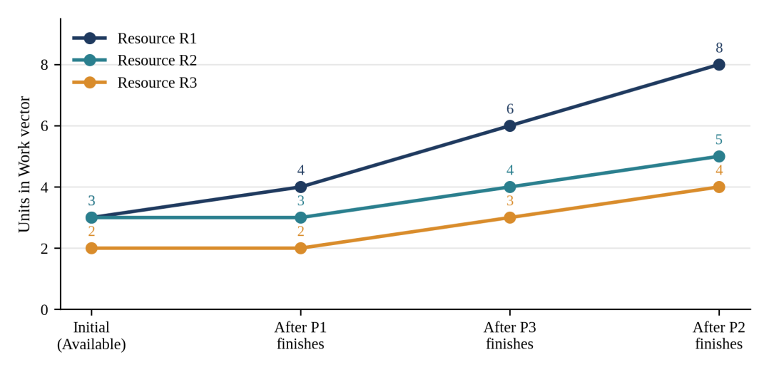
- Evolution of the Work vector while the safe sequence P1 → P3 → P2 is executed

Verified Functionality
The test runs verified the following functions of the program:
- Need matrix calculation
- Work vector update
- Finish status tracking
- Safe sequence generation
- Unsafe-state detection
- Exact-fit (≤) condition
Overall, the behaviour of the algorithm matches the expected safety logic for all three test cases.

Conclusion and Future Work
In this project a C-based Banker’s Algorithm Deadlock Checker was developed to verify safe resource allocation. The program computes the Need matrix, tracks the Work vector and Finish status of every process, decides whether the system is in a safe state, and generates a safe sequence when one exists. Testing with safe, unsafe and exact-fit cases showed that the implementation behaves according to the safety logic of the algorithm, including the inclusive comparison Need ≤ Work.
The current version reads its matrices from fixed values inside the program and checks a single system state. The following enhancements are planned as future work:
- Accept the matrices from the user at runtime.
- Handle live resource requests from processes.
- Check whether granting a new request keeps the system in a safe state.
- Reject requests that would lead to an unsafe state.
- Add input validation, for example for negative values and Max smaller than Allocation.
- Test the program with larger numbers of processes and resources.

Appendix A: C Source Code
The complete source code of the Deadlock Checker (data shown for Test Case 1) is listed below. Test Cases 2 and 3 use the same program with different values in the Allocation, Max and Available arrays.

#include <stdio.h>
#include <stdbool.h>

#define P 3 /* number of processes */
#define R 3 /* number of resource types */

int main(void)
{
/* ---- Input data (Test Case 1) ---- */
int allocation[P][R] = { {1, 0, 0},
{2, 1, 1},
{2, 1, 1} };
int max[P][R] = { {3, 2, 2},
{7, 4, 4},
{3, 1, 1} };
int available[R] = {3, 3, 2};

int need[P][R], work[R], safeSeq[P];
bool finish[P] = {false};
int count = 0, i, j;

printf("Banker's Algorithm - Deadlock Checker\n\n");
printf("Number of Processes: %d\n", P);
printf("Number of Resources: %d\n\n", R);

printf("Available Resources:\n");
for (j = 0; j < R; j++) printf("%d ", available[j]);
printf("\n\n");

/* Need = Max - Allocation */
printf("Need Matrix:\n");
for (i = 0; i < P; i++) {
printf("P%d: ", i + 1);
for (j = 0; j < R; j++) {
need[i][j] = max[i][j] - allocation[i][j];
printf("%d ", need[i][j]);
}
printf("\n");
}

/* Work = Available */
for (j = 0; j < R; j++) work[j] = available[j];

printf("\nChecking Safe State...\n\n");

while (count < P)
{
bool found = false;
for (i = 0; i < P; i++)

{
if (finish[i]) continue;

bool canRun = true;
for (j = 0; j < R; j++)
if (need[i][j] > work[j]) { canRun = false; break; }

if (canRun)
{
printf("P%d can execute\n", i + 1);
for (j = 0; j < R; j++) work[j] += allocation[i][j];
printf("Work updated: ");

for (j = 0; j < R; j++) printf("%d ", work[j]);
printf("\n\n");

safeSeq[count++] = i;
finish[i] = true;
found = true;
}
}
if (!found) {
/* no candidate -> UNSAFE */
printf("No remaining process satisfies Need <= Work\n\n");
printf("System is in an UNSAFE State\n");
return 1;
}
}

printf("System is in a SAFE State\n\n");
printf("Safe Sequence:\n");
for (i = 0; i < P; i++)
printf("P%d%s", safeSeq[i] + 1, (i < P - 1) ? " -> " : "\n");

return 0;
}

REFERENCES

[1] E. W. Dijkstra, “Een algorithme ter voorkoming van de dodelijke omarming,” EWD-108, Technische Hogeschool Eindhoven, 1965.
[2] A. N. Habermann, “Prevention of system deadlocks,” Communications of the ACM, vol. 12, pp. 373–377, 1969.
[3] E. G. Coffman, M. J. Elphick, and A. Shoshani, “System deadlocks,” ACM Computing Surveys, vol. 3, pp. 67–78, 1971.
[4] A. Silberschatz, P. B. Galvin, and G. Gagne, Operating System Concepts, 10th ed. Wiley, 2018.
[5] A. S. Tanenbaum and H. Bos, Modern Operating Systems, 4th ed. Pearson, 2015.
[6] B. W. Kernighan and D. M. Ritchie, The C Programming Language, 2nd ed. Prentice Hall, 1988.

